PROJECT PROPOSAL
GoNano Roof Protection System

Prepared For
Robert Thompson
789 Maple Drive
Boca Raton, FL 33432

Date: January 15, 2025

Professional GoNano Application
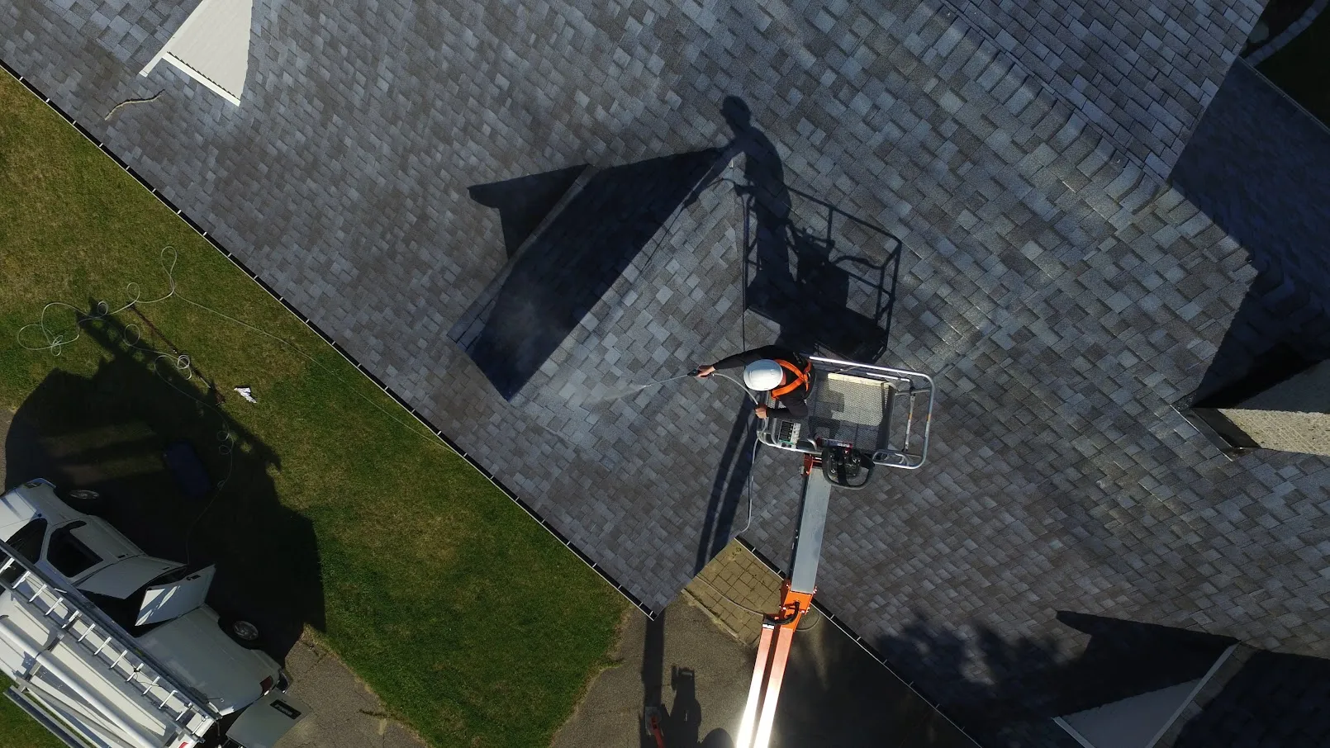
Extending Roof Life with Advanced Nanotechnology

COMPANY PROFILE
Transforming roof protection with cutting-edge nanotechnology solutions across the Mid-Atlantic United States
We believe that every property deserves protection that lasts. Our journey began with a commitment to bringing innovative nanotechnology solutions to property owners who demand excellence and longevity from their roofing investments.

Our Experience
Green Energy Construction & Consulting has over 15 years of experience developing and installing thousands of renewable energy projects for home and business owners. It is through this experience we recognized a clear need and our Roof Recharge division was born.

Why We're Different
We recognized that traditional roofing treatments offered short-term protection at best. We partnered with GoNano to deliver cutting-edge nanotechnology solutions that strengthen durability and extend roof lifespan by decades, providing our customers with true long-term value.

Our Service Area
Today, we serve property owners throughout the Mid-Atlantic United States, combining our construction expertise with revolutionary GoNano technology to protect investments and reduce maintenance costs for years to come.

Our Commitment
✓ Authorized GoNano Installer - Fully certified and trained in advanced application techniques
✓ Proven Track Record - Thousands of successful installations over 15+ years
✓ Long-Term Protection - Solutions that extend roof life by decades, not just years
✓ True Value - Cost-effective alternatives to premature roof replacement

PROJECT DESCRIPTION
Property Address | 789 Maple Drive, Boca Raton, FL 33432
Roof Area | 2800 sq ft
Roof Type | Architectural Shingle
Roof Age | 4 years
[Aerial image will be inserted here]

Proposed GoNano Solution
Based on our inspection and analysis of your roof, we recommend:
GoNano Shingle Saver
Perfect for your newer roof (0-7 years old), this advanced nanotechnology formula will protect your investment for decades to come.

Product Overview
GoNano Shingle Saver is a nanotechnology-driven clear and breathable penetrating sealer for asphalt shingles. Using advanced nano-particles that connect to the aggregate and bitumen, it creates a hydrophobic environment that dramatically extends roof life.
KEY FEATURES  ✓ FORTIFY  Significantly enhances impact resistance  ✓ ENHANCE  Improves wind and weather resistance  ✓ PRESERVE  Creates hydrophobic barrier  ✓ LONGEVITY  Extends roof life up to 15 years | PROVEN RESULTS  • Aging reduction up to 68%  • 100% breathable protection  • Resists freeze-thaw damage  • Prevents organic growth  • Natural flat finish  • UL & IBHS tested  • 5-15 year warranty
Additional Notes: Customer's 4-year-old roof is in excellent condition. Shingle Saver will provide maximum protection with its nanotechnology-driven formula, creating a hydrophobic barrier that prevents damage and extends roof life.

INVESTMENT & SAVINGS ANALYSIS
Description | Amount
GoNano Saver Application (2800 sq ft) | $6300.00
Professional Installation | $425.00
Total Investment | $6725.00

Cost Comparison
Full Roof Replacement  $24500.00  (Typical cost: $8.75/sq ft) | GoNano Protection  $6725.00  Your Savings: $17775.00

AUTHORIZATION TO PROCEED
By signing below, you authorize Roof Recharge by Green Energy Construction & Consulting to proceed with the GoNano application as outlined in this proposal.
_______________________________
Customer Signature
_______________________________
Customer Name (Print)
_______________________________
Date
_______________________________
Jennifer Martinez
_______________________________
Date

TERMS AND CONDITIONS
1. SCOPE OF WORK
Roof Recharge will apply GoNano nanotechnology protection to the specified roof area. This includes roof inspection, cleaning as necessary, and professional application of the GoNano product.
2. WARRANTY
GoNano products are warranted for 10-15 years depending on roof condition. This warranty covers the performance of the GoNano coating and does not void existing shingle manufacturer warranties.
3. PAYMENT TERMS
Payment is due upon completion of application. We accept cash, check, and major credit cards.
4. WEATHER CONDITIONS
Application requires dry conditions. If weather prevents application, we will reschedule at the earliest convenient time.
5. LIABILITY
Roof Recharge and GoNano are not responsible for pre-existing roof conditions or damage. Our inspection will identify any issues that may affect warranty coverage.
6. ENVIRONMENTAL SAFETY
GoNano products are environmentally friendly with no harmful chemicals. The products are safe for vegetation, animals, and humans.
7. ADDITIONAL FEES
Additional fees may apply for structural changes, shingle replacements, or specialized installation equipment such as boom trucks. Any such additional costs will be discussed and approved before work proceeds.

